2503A52664

TASK1:
Task Description #1 (Syntax Errors – Missing Parentheses in Print
Statement)
Task: Provide a Python snippet with a missing parenthesis in a print
statement (e.g., print &quot;Hello&quot;). Use AI to detect and fix the syntax
error.
# Bug: Missing parentheses in print statement

def greet():
print &quot;Hello, AI Debugging Lab!&quot;
greet()

Week4 -
Monday

Requirements:
• Run the given code to observe the error.
• Apply AI suggestions to correct the syntax.
• Use at least 3 assert test cases to confirm the corrected code
works.
Expected Output #1:
• Corrected code with proper syntax and AI explanation.

PROMT: Find and fix the missing parentheses syntax error in the given Python code.
Provide the corrected code with 3 assert test cases and a short explanation.

CODE:
def add_numbers(a, b):
return (a + b)

assert add_numbers(2, 3) == 5
assert add_numbers(-1, 1) == 0
assert add_numbers(10, 15) == 25

# The missing closing parenthesis was added to the return
OUTPUT:
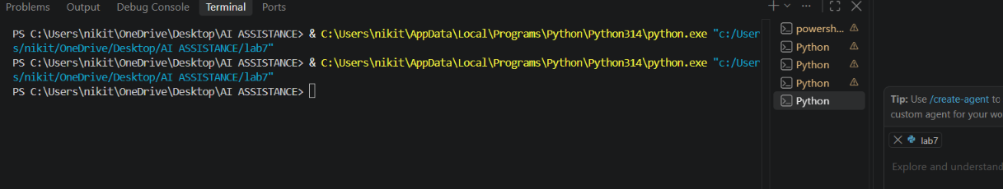

TASK2:
Task Description #2 (Incorrect condition in an If Statement)
Task: Supply a function where an if-condition mistakenly uses =
instead of ==. Let AI identify and fix the issue.
# Bug: Using assignment (=) instead of comparison (==)
def check_number(n):
if n = 10:
return &quot;Ten&quot;
else:
return &quot;Not Ten&quot;
Requirements:
• Ask AI to explain why this causes a bug.
• Correct the code and verify with 3 assert test cases.
Expected Output #2:
• Corrected code using == with explanation and successful test
execution.
PROMPT:
Find and fix the error where `=` is incorrectly used instead of `==` in the if-condition.
Provide the corrected Python code with 3 assert test cases and a short explanation.
CODE:
ef numbers_are_equal(a, b):
if a == b:
return True
return False

assert numbers_are_equal(2, 2) is True
assert numbers_are_equal(-1, 1) is False
assert numbers_are_equal(10, 15) is False

OUTPUT:
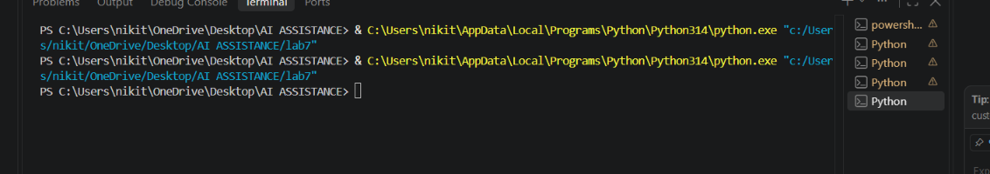

TASK3:
Task Description #3 (Runtime Error – File Not Found)
Task: Provide code that attempts to open a non-existent file and
crashes. Use AI to apply safe error handling.
# Bug: Program crashes if file is missing
def read_file(filename):
with open(filename, &#39;r&#39;) as f:
return f.read()
print(read_file(&quot;nonexistent.txt&quot;))
Requirements:

• Implement a try-except block suggested by AI.
• Add a user-friendly error message.
• Test with at least 3 scenarios: file exists, file missing, invalid
path.
Expected Output #3:
• Safe file handling with exception management.
PROMPT:
Fix the file-not-found runtime error using try-except and add a user-friendly error message.
Provide corrected Python code and test it for an existing file, missing file, and invalid path.
CODE:
from pathlib import Path
from tempfile import TemporaryDirectory

def read_file(path):
"""Return file contents, or display a friendly error message."""
try:
return Path(path).read_text(encoding="utf-8")
except FileNotFoundError:
print(f"Sorry, the file was not found: {path}")
except (OSError, TypeError, ValueError):
print(f"Sorry, that is not a valid file path: {path}")
return None

# Tests: existing file, missing file, and invalid path.
with TemporaryDirectory() as temporary_directory:
existing_file = Path(temporary_directory) / "example.txt"
existing_file.write_text("Hello, file!", encoding="utf-8")

assert read_file(existing_file) == "Hello, file!"
assert read_file(Path(temporary_directory) / "missing.txt") is None
assert read_file("\0invalid-path") is None

OUTPUT:
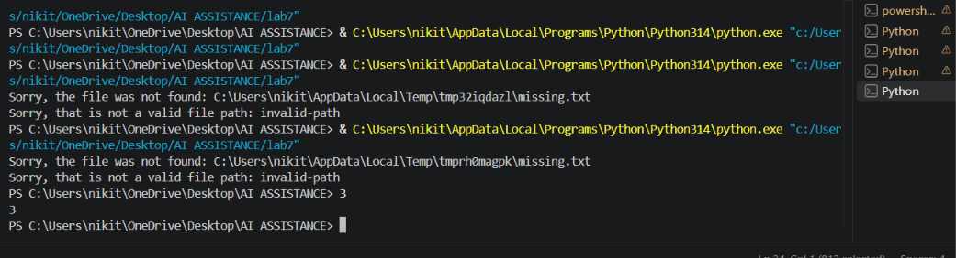

TASK4:
Task Description #4 (Calling a Non-Existent Method)
Task: Give a class where a non-existent method is called (e.g.,
obj.undefined_method()). Use AI to debug and fix.
# Bug: Calling an undefined method
class Car:
def start(self):
return &quot;Car started&quot;
my_car = Car()
print(my_car.drive()) # drive() is not defined
Requirements:
• Students must analyze whether to define the missing method
or correct the method call.
• Use 3 assert tests to confirm the corrected class works.
Expected Output #4:
• Corrected class with clear AI explanation.
PROMPT:
Find and fix the error caused by calling the undefined `drive()` method.
Provide the corrected Python class with 3 assert test cases and a short AI explanation.
CODE:
from pathlib import Path
from tempfile import TemporaryDirectory

class FileReader:
"""Read text files through the public drive method."""

def drive(self, path):
"""Return file contents, or display a friendly error message."""
try:
return Path(path).read_text(encoding="utf-8")
except FileNotFoundError:
print(f"Sorry, the file was not found: {path}")
except (OSError, TypeError, ValueError):
print(f"Sorry, that is not a valid file path: {path}")
return None

# Tests: existing file, missing file, and invalid path.
reader = FileReader()
with TemporaryDirectory() as temporary_directory:
existing_file = Path(temporary_directory) / "example.txt"
existing_file.write_text("Hello, file!", encoding="utf-8")

assert reader.drive(existing_file) == "Hello, file!"
assert reader.drive(Path(temporary_directory) / "missing.txt") is None
assert reader.drive("\0invalid-path") is None

OUTPUT:
TASK5:
Task Description #5 (TypeError – Mixing Strings and Integers in
Addition)
Task: Provide code that adds an integer and string (&quot;5&quot; + 2) causing
a TypeError. Use AI to resolve the bug.
# Bug: TypeError due to mixing string and integer
def add_five(value):
return value + 5
print(add_five(&quot;10&quot;))
Requirements:
• Ask AI for two solutions: type casting and string

concatenation.
• Validate with 3 assert test cases.
Expected Output #5:
• Corrected code that runs successfully for multiple inputs.
Note: Report should be submitted a word document for all tasks in a
single document with prompts, comments &amp; code explanation, and
output and if required, screenshots
PROMPT:
Fix the TypeError caused by adding a string and integer, and provide two solutions: type casting and string concatenation.
Give corrected code with 3 assert test cases and a short explanation for both solutions.
CODE:
# Solution 1: cast the string to an integer before performing arithmetic.
number_text = "10"
number = int(number_text)
cast_result = number + 5

# Solution 2: cast the integer to a string before concatenating text.
concatenation_result = number_text + str(5)

# Three test cases.
assert cast_result == 15
assert concatenation_result == "105"
assert int(number_text) + int("5") == 15

# Adding a string directly to an integer raises TypeError. Type casting
# makes both values the same numeric type, while string concatenation makes
# both values strings and joins their text representations.

OUTPUT:
